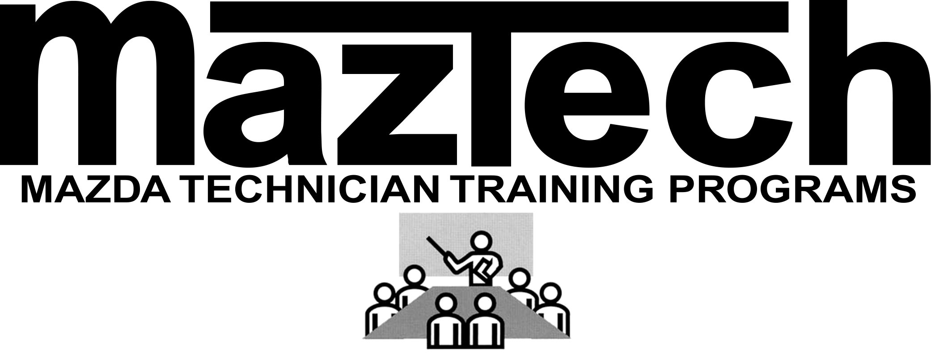

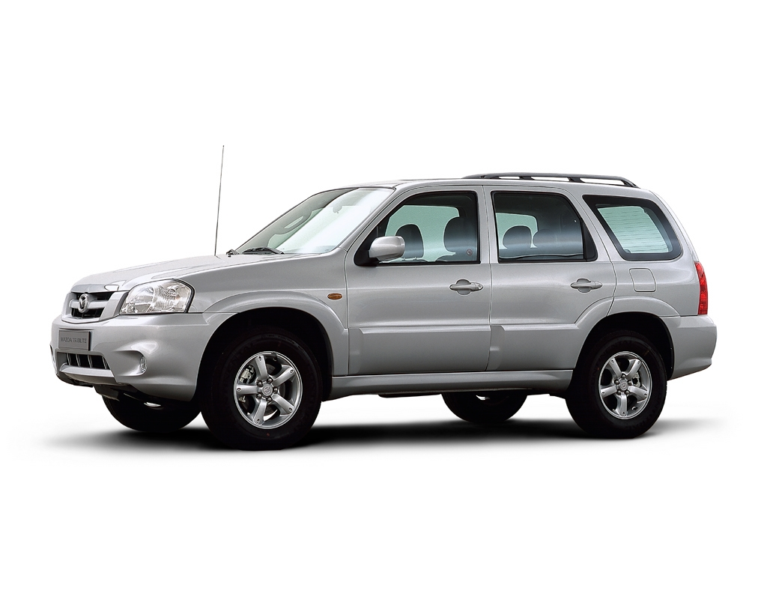

TRAINING MANUAL

Tribute Facelift



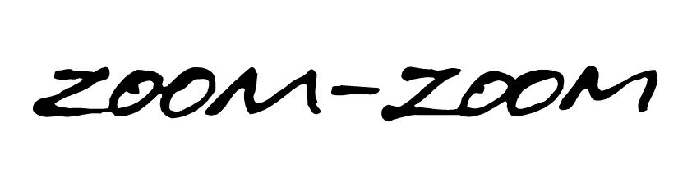

MME Technical Training 2004

No part of this hardcopy may be reproduced in any form without prior permission of Mazda Motor Europe GmbH.

The illustrations, technical information, data and descriptive text in this issue, to the best of our knowledge, were correct at the time of going to print.

No liability can be accepted for any inaccuracies or omissions in this publication, although every possible care has been taken to make it as complete and accurate as possible.

© 2004
Mazda Motor Europe GmbH

Technical Training Department

